For Immediate Release
Contact: Dana Brosilovski
Tecom Electronics Ltd.
+1-888-504-6444
dana@tecom.co.il

Multi-Touch Technology Reaches the Classroom: Tecom Launches New AV Lecterns
Introducing the All-New TecPodium Interactive with Multitouch Capabilities

Rosh Haayin, Israel and Orlando, Florida – May 21, 2013 – Tecom launches its latest TecPodium AV Lectern with multi-touch screen capabilities supporting Microsoft Windows 8 and HD resolution. “The New TecPodium now meets all presenters' need with the latest technology approach” says Aviv Brosilovski, Tecom CEO.

The TecPodium TPI-12W is an all-in-one lectern with a single control panel for all the integrated Audio-Visual equipment. Now, the lectern has a built-in optical, multiuser touch screen system, employing state of the art technology to achieve high-resolution, high brightness, fast and accurate response with no calibration requirements.

The new touch screen offers extended educational tools for the modern classroom and training environments where the presenter can use all common touch gestures such as swipe, tap, slide, scroll, zoom and more directly on the podium screen. TecPodium multi-touch screen fully supports Microsoft Windows 8 and Microsoft Office 2013 inking features, allowing direct, on the fly annotation capabilities.

Aviv Brosilovski, Tecom CEO: “Over the last couple of years we’ve witnessed a dramatic growth in the use of smartphones and tablet applications in the educational environment. Faculty wants to keep up with the trend and bridge over the “generation gap” with their younger students. What could be simpler than adopting the multi-touch screen, commonly used by the presenter in his smartphone, into his teaching station – the TecPodium! Presenters no longer have to undergo extensive training on racks full of amplifiers, controls, and switches; they can now focus on their messages, not the technology.”

TecPodiums have rapidly become the lectern-of-choice. Across the globe educational institutions, government facilities, hospitals, corporations and military are all installing TecPodium lecterns.

Tecom will be displaying the new TecPodium Lectern and its latest technology at InfoComm 2013, on June 12-14 at the Orange County Convention Center, Orlando, Florida. Tecom will be at Booth # 2481.

About Tecom
Tecom Electronics is a dynamic company continuously developing and evolving their products to provide the simplest yet most technologically advanced solution to managing Audio Visual equipment in training and educational facilities. Tecom replaces generic podiums in the classroom and boardroom with a more interactive and easy to use technological experience. Tecom Electronics is ISO 9001:2008 certified.
www.tecpodium.com

Photo of the TecPodium new Multi-Touch screen

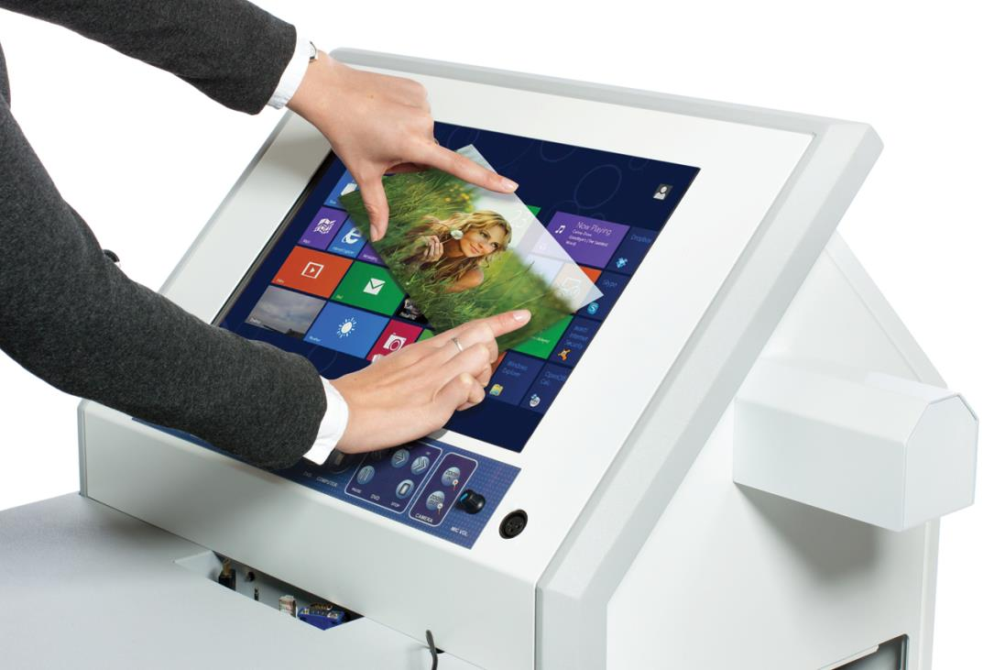

Link to High Resolution Image – CLICK HERE

